COMPUTER-AIDED DESIGN I REPORT
Lecturer: Dr. Henriette Bier
CAD Instructor: Max Latour

Student ID: 16759
Nguyen Vu Minh Thu
Vietnamese German University

Introduction
To create the virtual model of the separator project, Rhino 7 application was employed. There was mainly 4 stages of the Computer-aided design including Replica remodeling, Conceptual design, Design development and Materialisation design. All the stages were based on lectures of the Architectural Design I/ CAD I workshop with Modeling videos, Culture and Society lectures, Measure of Man lectures and Design Studio lectures respectively.

Methodology

Replica remodeling
The process of remodeling provides a way to experiment with ideas while constructing a 3D model of the Denari project (Denari Project, n.d.). The complicated envelop design and construction dimensions were explored during process. This allows for the determination of problems exist in the previous design and a more familiar use of the Rhino application.
The void space at the frame structure and the staircase leading to the floor were the two discomforts that were identified. Therefore, a new project was started with the idea of having a separator that protect the design studio from unwanted glare and provide a smooth path rather than a leveling floor with stairs connecting between the two spaces.

Conceptual design
From the identification of issues existing in the precedent, conceptual design of a new separator was carried out. The new design put in priority the fulfilment of requirements and solution for the problems. A common space with a garden, acts like an indoor pavilion was then introduced, with respect to the separator’s interaction with human needs and the dimensions of human activities happen in the separator.
Drawing from the concept of lines and random composition of solid shapes, the projects leaves the impression of a deconstructivism design. A new envelop of the separator was proposed using those elements creating a full privacy screen with small and unique windows that have the same pattern. The leveling frame and the door were removed, rather than that, a hallway with U-shape was applied to the pavilion to provide a better comfort for the occupants.

Design development
With that idea, the project was further developed with respect to the human dimensions and activities. Studies on the development of space and form in relation to human behavior patterns and motion sequences were carried out. Human activities that were considered was sitting, standing and in movement, thus, the design fulfil these activities with its random-but-in-order shapes and forms. Neufert architects’ data was used in this stage to precisely scale the furniture and walkway (Neufert, 2019). The virtual 3D model design was conducted mostly using polylines that extruded to the desired shapes.
Materialisation design
In the materialization stage, the possibility of an applicable material was processed. Wood was introduced to the project because of the characteristics of a quick, simple and lightweight construction. Two colors of wood was applied to emphasis the differences in functions and highlight the deconstructivism elements.

Discussion
The design was lastly finished in Rhino 7 application for perspective visualization. The result provides a better imagination of the first idea with the possibility to construct the separator. The 3D model also supports the faster physical 3D model making that developed through the use of foam core board.

References

Denari Project. (n.d.). http://cs.roboticbuilding.eu/pdf/1_Denari_Project.pdf
Neufert, E. N. and P. (2019). Neufert architects’ data. In Journal of Chemical Information and Modeling (Vol. 53, Issue 9).

Appendices
Rendering

Perspective view

The green wall

Interior front view

Interior left view

Interior back view
Exterior back view

Plans and sections
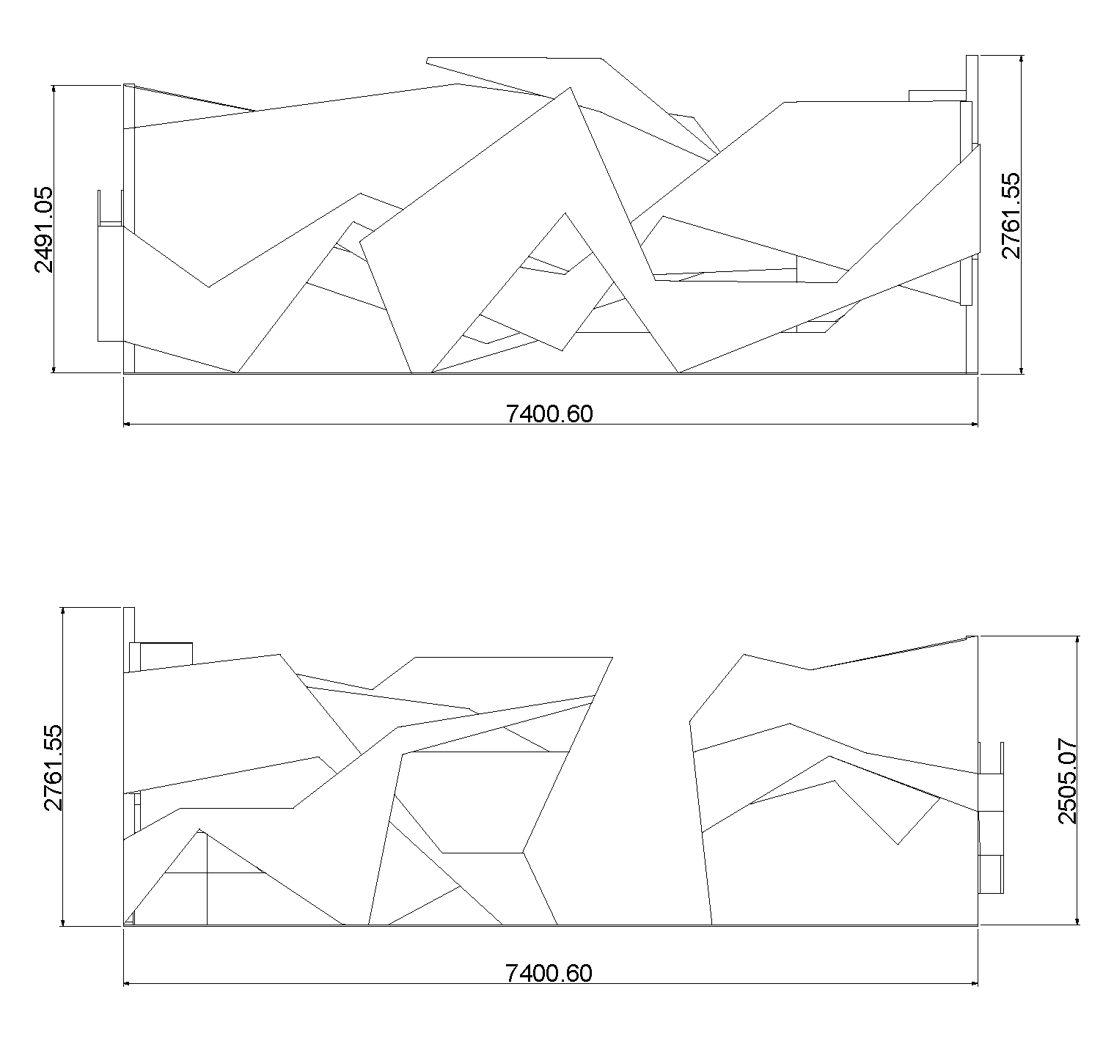
Back view – Front view

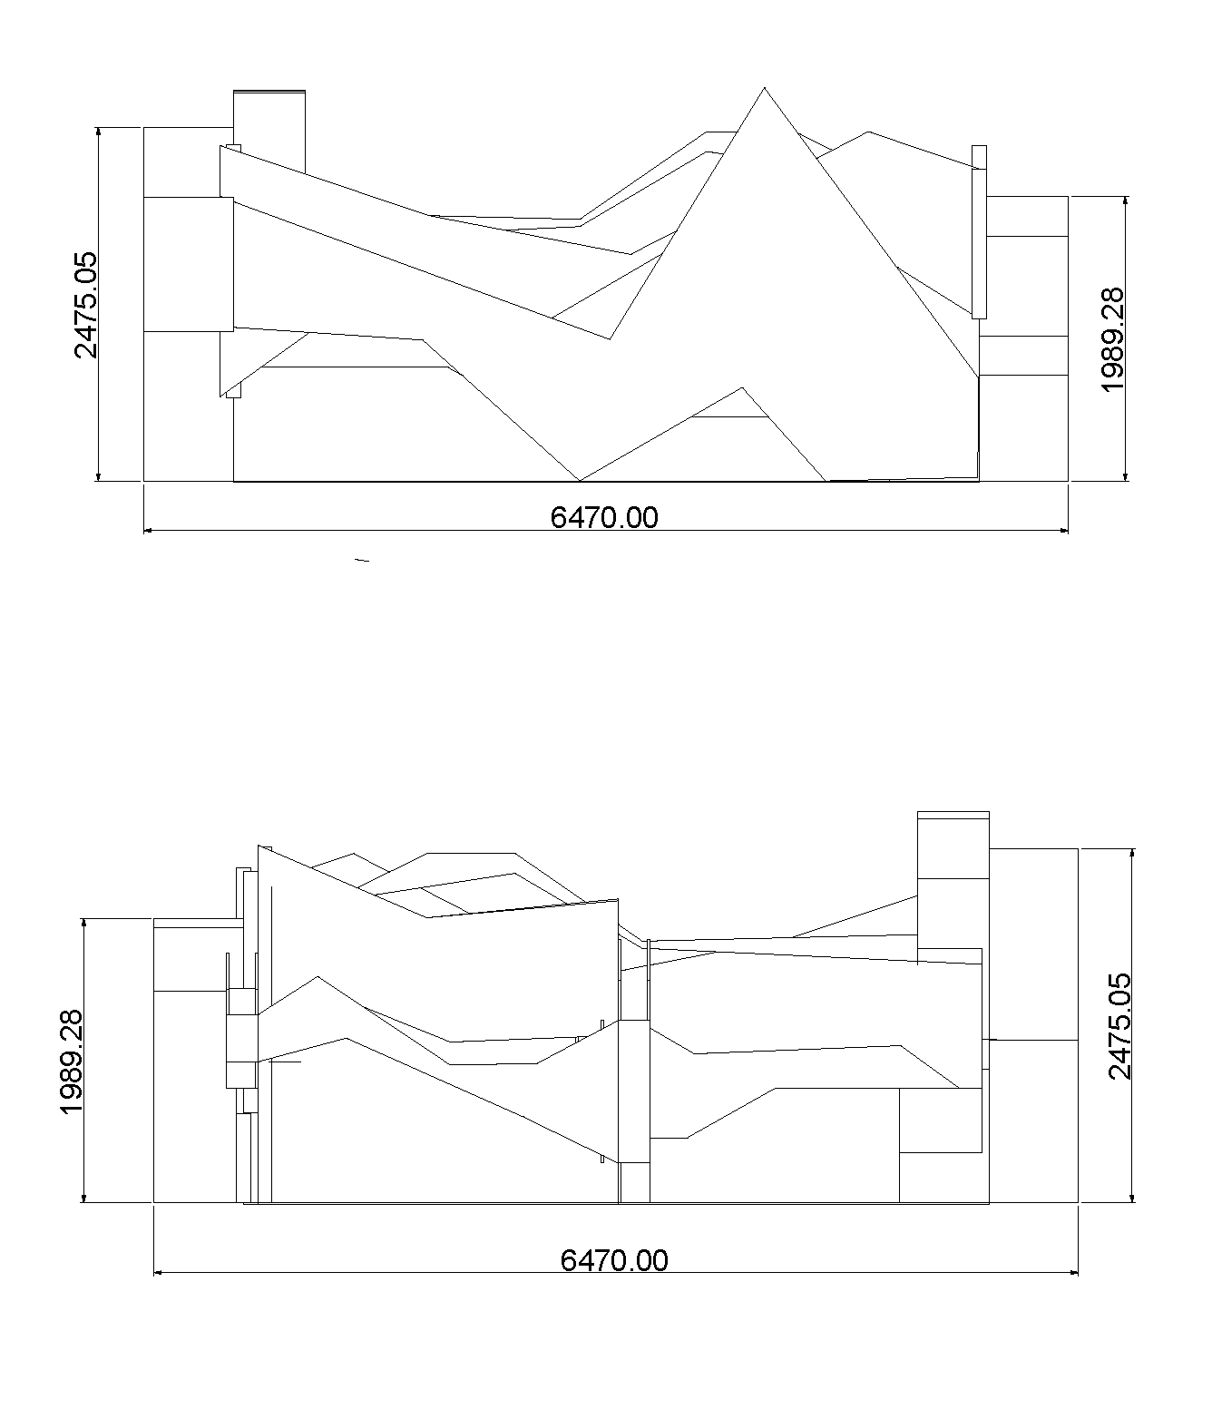
Left view - Right view

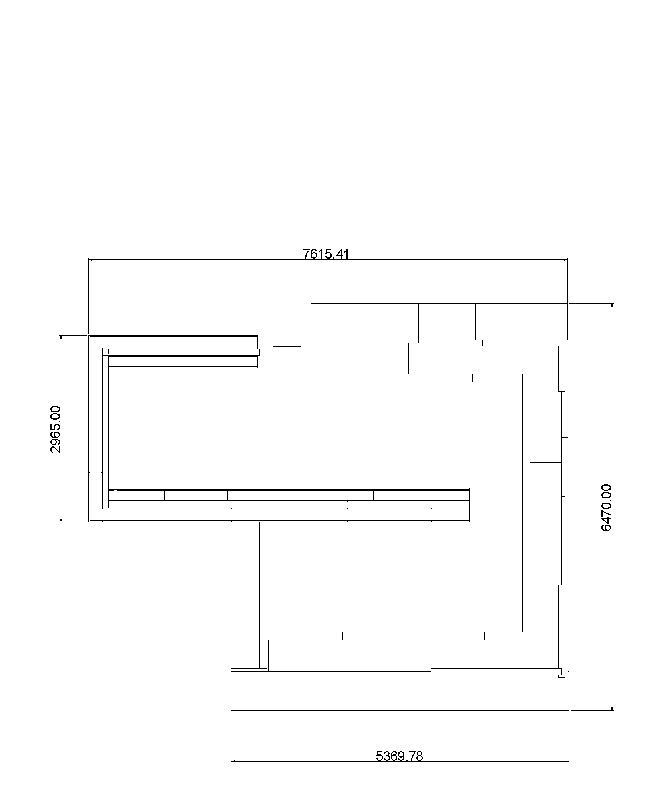
Top view

