Computer Aided design I
Nguyen Hoang Vinh Loc-14349
CONCEPTUAL
Every building starts with creating ideas, these ideas came from analyzing the goals, purposes and values that the owner of the building needs. The architect can then develop a concept for the building and from there is where the building will starts coming to life.
For this project (The Denari project), it is said that the owner, the company called “Details”, requested for a “wall” to separate a 2000 square-foot spaces into 2 discrete spaces, one is a design studio and the other is an entry, the “wall” also has other functions such as storage or a worktable.
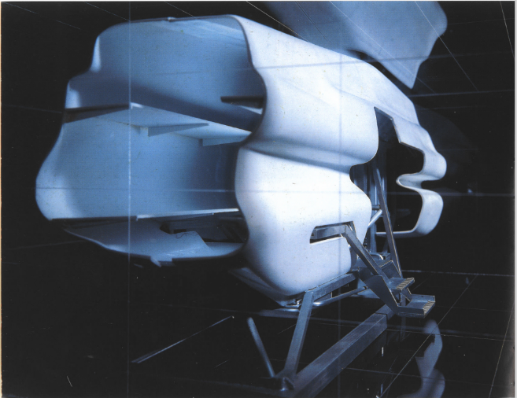
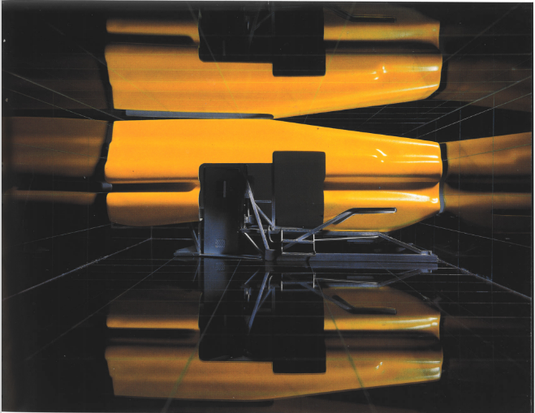

Denari Project

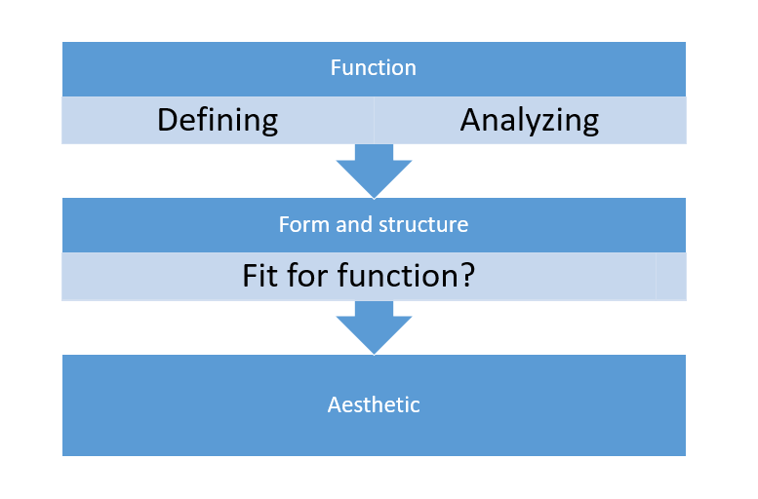
The task given to the students was to develop and renovate the construction to their liking while maintaining the original function. Given this project, the design process started with defining the necessary functions as well as other function that I want integrate into the design. From there, the shape of the construction would be decided to fit the requirement for the function. Lastly is the aesthetic, after forming the structure, other characteristics would be considered in order to make the construction aesthetically pleasing.

I. Function
The preliminary and most important purpose for this construction is to separate the space into 2 sections with different but related function. Aside from that, other functions added to the design are storage, exhibiting and since there are customers and employees in the studio, a resting area has been created in order to meet the needs.

II. Form and structure
After defining all the functions for the construction, comes the form and structure. The construction was created following the minimalize route, with lots of space inside. The construction took a form of a cube to maximize the space inside
After deciding the form of the building, I started to sketch-out the form and layout of the construction. There are two areas, one is for storage and exhibiting and the other is the resting area. Talking about the resting area, I design this area specifically to be a place where visitors can sit down, relax, have a cup of coffee, read some books or talk with others, a place where employees can take a break in after hours of working hard. There is also a kitchen built in the area for the employees to use.
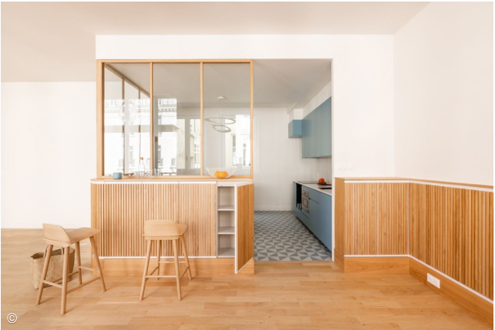

Triplex in Paris

This design inspiration was given from the Triplex in Paris by Bertina Minel

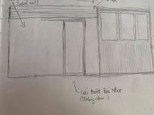
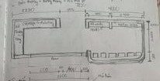

Sketches
III. Material
The material that I decided to go with for this project are mainly stones a. For the base and walls, I used stones to create a firm texture for the whole building. The furniture for the construcion are made of wood to add a natural aura to the area, thus making the place more comfortable and relaxing to stay in.
DEVELOPMENT
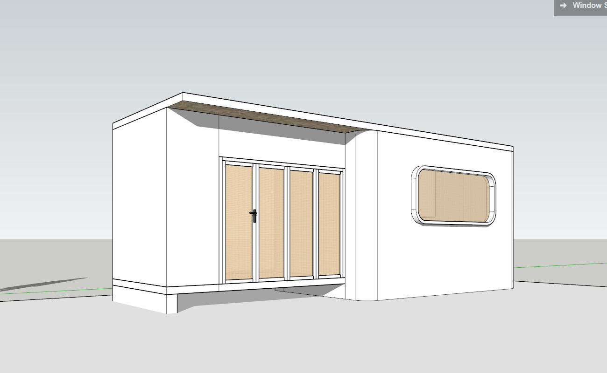
Finally, I started working with the software to create a model for further observation and tweaking.

First model
The only adjustment done was to the base on the left side of the building. By removing the gap completely, the “wall” would completely separate the two area, blocking off any sounds or distortion from coming to the design studio, creating a quiet environment for the studio.
Other than that, the model has also been refined to look aesthetically pleasing.

References:
Koya-no-sumika Japanese minimalist plywood extension by ma-style architects:
Koya No Sumika Japanese Minimalist Plywood Extension by mA-style Architects - Homeli
Triplex in Paris- Bertina Minel
Triplex in Paris / Bertina Minel Architecture | ArchDaily
Denari Project:
1_Denari_Project.pdf (roboticbuilding.eu)

Appendices
